PERHITUNGAN TANGGAPAN RESPONDEN

**Kepemimpinan Transformasional**























##### Lingkungan Kerja

























**Beban Kerja**



















**Intention to Leave**

















**Kinerja Karyawan**

























**ANALISA SMART-PLS**

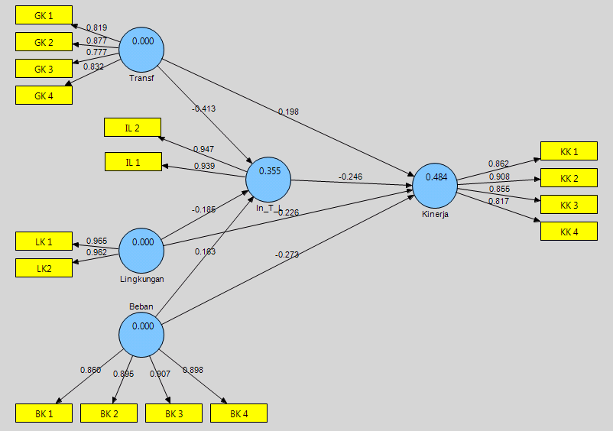

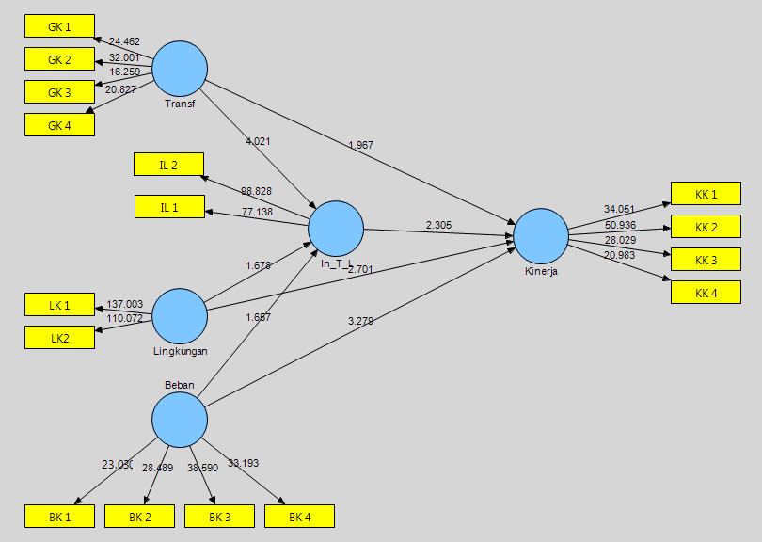

**Structural Model Specification**

**Quality Criteria**

**Overview**

|  |  |  |  |  |  |
| --- | --- | --- | --- | --- | --- |
|  | **AVE** | **Composite Reliability** | **R Square** | **Cronbachs Alpha** | **Communality** |
| **Beban** | 0.793 | 0.939 |  | 0.914 | 0.793 |
| **In_T_L** | 0.889 | 0.941 | 0.355 | 0.875 | 0.889 |
| **Kinerja** | 0.741 | 0.920 | 0.484 | 0.883 | 0.741 |
| **Lingkungan** | 0.928 | 0.962 |  | 0.922 | 0.928 |
| **Transf** | 0.684 | 0.896 |  | 0.846 | 0.684 |

**Redundancy**

|  |  |  |  |  |  |
| --- | --- | --- | --- | --- | --- |
|  | **redundancy** |  |  |  |  |
| **Beban** |  |  |  |  |  |
| **In_T_L** | 0.088 |  |  |  |  |
| **Kinerja** | 0.153 |  |  |  |  |
| **Lingkungan** |  |  |  |  |  |
| **Transf** |  |  |  |  |  |

**Cronbachs Alpha**

|  |  |  |  |  |  |
| --- | --- | --- | --- | --- | --- |
|  | **Cronbachs Alpha** |  |  |  |  |
| **Beban** | 0.914 |  |  |  |  |
| **In_T_L** | 0.875 |  |  |  |  |
| **Kinerja** | 0.883 |  |  |  |  |
| **Lingkungan** | 0.922 |  |  |  |  |
| **Transf** | 0.846 |  |  |  |  |

**Latent Variable Correlations**

|  |  |  |  |  |  |
| --- | --- | --- | --- | --- | --- |
|  | **Beban** | **In_T_L** | **Kinerja** | **Lingkungan** | **Transf** |
| **Beban** | 1.000 |  |  |  |  |
| **In_T_L** | 0.385 | 1.000 |  |  |  |
| **Kinerja** | -0.519 | -0.543 | 1.000 |  |  |
| **Lingkungan** | -0.328 | -0.376 | 0.474 | 1.000 |  |
| **Transf** | -0.392 | -0.538 | 0.513 | 0.335 | 1.000 |

**R Square**

|  |  |  |  |  |  |
| --- | --- | --- | --- | --- | --- |
|  | **R Square** |  |  |  |  |
| **Beban** |  |  |  |  |  |
| **In_T_L** | 0.355 |  |  |  |  |
| **Kinerja** | 0.484 |  |  |  |  |
| **Lingkungan** |  |  |  |  |  |
| **Transf** |  |  |  |  |  |

**Cross Loadings**

|  |  |  |  |  |  |
| --- | --- | --- | --- | --- | --- |
|  | **Beban** | **In_T_L** | **Kinerja** | **Lingkungan** | **Transf** |
| **BK 1** | 0.860 | 0.245 | -0.350 | -0.288 | -0.259 |
| **BK 2** | 0.895 | 0.295 | -0.417 | -0.200 | -0.358 |
| **BK 3** | 0.907 | 0.381 | -0.544 | -0.293 | -0.316 |
| **BK 4** | 0.898 | 0.411 | -0.493 | -0.370 | -0.440 |
| **GK 1** | -0.301 | -0.422 | 0.462 | 0.357 | 0.819 |
| **GK 2** | -0.396 | -0.523 | 0.453 | 0.295 | 0.877 |
| **GK 3** | -0.234 | -0.436 | 0.314 | 0.237 | 0.777 |
| **GK 4** | -0.351 | -0.394 | 0.455 | 0.212 | 0.832 |
| **IL 1** | 0.327 | 0.939 | -0.463 | -0.363 | -0.530 |
| **IL 2** | 0.398 | 0.947 | -0.557 | -0.347 | -0.487 |
| **KK 1** | -0.395 | -0.448 | 0.862 | 0.408 | 0.516 |
| **KK 2** | -0.554 | -0.440 | 0.908 | 0.472 | 0.457 |
| **KK 3** | -0.487 | -0.522 | 0.855 | 0.350 | 0.431 |
| **KK 4** | -0.330 | -0.464 | 0.817 | 0.400 | 0.356 |
| **LK 1** | -0.336 | -0.396 | 0.444 | 0.965 | 0.368 |
| **LK2** | -0.295 | -0.328 | 0.469 | 0.962 | 0.274 |

**AVE**

|  |  |  |  |  |  |
| --- | --- | --- | --- | --- | --- |
|  | **AVE** |  |  |  |  |
| **Beban** | 0.793 |  |  |  |  |
| **In_T_L** | 0.889 |  |  |  |  |
| **Kinerja** | 0.741 |  |  |  |  |
| **Lingkungan** | 0.928 |  |  |  |  |
| **Transf** | 0.684 |  |  |  |  |

**Communality**

|  |  |  |  |  |  |
| --- | --- | --- | --- | --- | --- |
|  | **communality** |  |  |  |  |
| **Beban** | 0.793 |  |  |  |  |
| **In_T_L** | 0.889 |  |  |  |  |
| **Kinerja** | 0.741 |  |  |  |  |
| **Lingkungan** | 0.928 |  |  |  |  |
| **Transf** | 0.684 |  |  |  |  |

**Total Effects**

|  |  |  |  |  |  |
| --- | --- | --- | --- | --- | --- |
|  | **Beban** | **In_T_L** | **Kinerja** | **Lingkungan** | **Transf** |
| **Beban** |  | 0.163 | -0.313 |  |  |
| **In_T_L** |  |  | -0.246 |  |  |
| **Kinerja** |  |  |  |  |  |
| **Lingkungan** |  | -0.185 | 0.271 |  |  |
| **Transf** |  | -0.413 | 0.300 |  |  |

**Composite Reliability**

|  |  |  |  |  |  |
| --- | --- | --- | --- | --- | --- |
|  | **Composite Reliability** |  |  |  |  |
| **Beban** | 0.939 |  |  |  |  |
| **In_T_L** | 0.941 |  |  |  |  |
| **Kinerja** | 0.920 |  |  |  |  |
| **Lingkungan** | 0.962 |  |  |  |  |
| **Transf** | 0.896 |  |  |  |  |

**Outer Loadings**

|  |  |  |  |  |  |
| --- | --- | --- | --- | --- | --- |
|  | **Beban** | **In_T_L** | **Kinerja** | **Lingkungan** | **Transf** |
| **BK 1** | 0.860 |  |  |  |  |
| **BK 2** | 0.895 |  |  |  |  |
| **BK 3** | 0.907 |  |  |  |  |
| **BK 4** | 0.898 |  |  |  |  |
| **GK 1** |  |  |  |  | 0.819 |
| **GK 2** |  |  |  |  | 0.877 |
| **GK 3** |  |  |  |  | 0.777 |
| **GK 4** |  |  |  |  | 0.832 |
| **IL 1** |  | 0.939 |  |  |  |
| **IL 2** |  | 0.947 |  |  |  |
| **KK 1** |  |  | 0.862 |  |  |
| **KK 2** |  |  | 0.908 |  |  |
| **KK 3** |  |  | 0.855 |  |  |
| **KK 4** |  |  | 0.817 |  |  |
| **LK 1** |  |  |  | 0.965 |  |
| **LK2** |  |  |  | 0.962 |  |

**Outer Model (Weights or Loadings)**

|  |  |  |  |  |  |
| --- | --- | --- | --- | --- | --- |
|  | **Beban** | **In_T_L** | **Kinerja** | **Lingkungan** | **Transf** |
| **BK 1** | 0.860 |  |  |  |  |
| **BK 2** | 0.895 |  |  |  |  |
| **BK 3** | 0.907 |  |  |  |  |
| **BK 4** | 0.898 |  |  |  |  |
| **GK 1** |  |  |  |  | 0.819 |
| **GK 2** |  |  |  |  | 0.877 |
| **GK 3** |  |  |  |  | 0.777 |
| **GK 4** |  |  |  |  | 0.832 |
| **IL 1** |  | 0.939 |  |  |  |
| **IL 2** |  | 0.947 |  |  |  |
| **KK 1** |  |  | 0.862 |  |  |
| **KK 2** |  |  | 0.908 |  |  |
| **KK 3** |  |  | 0.855 |  |  |
| **KK 4** |  |  | 0.817 |  |  |
| **LK 1** |  |  |  | 0.965 |  |
| **LK2** |  |  |  | 0.962 |  |

**Path Coefficients**

|  |  |  |  |  |  |
| --- | --- | --- | --- | --- | --- |
|  | **Beban** | **In_T_L** | **Kinerja** | **Lingkungan** | **Transf** |
| **Beban** |  | 0.163 | -0.273 |  |  |
| **In_T_L** |  |  | -0.246 |  |  |
| **Kinerja** |  |  |  |  |  |
| **Lingkungan** |  | -0.185 | 0.226 |  |  |
| **Transf** |  | -0.413 | 0.198 |  |  |

**Outer Weights**

|  |  |  |  |  |  |
| --- | --- | --- | --- | --- | --- |
|  | **Beban** | **In_T_L** | **Kinerja** | **Lingkungan** | **Transf** |
| **BK 1** | 0.213 |  |  |  |  |
| **BK 2** | 0.255 |  |  |  |  |
| **BK 3** | 0.332 |  |  |  |  |
| **BK 4** | 0.320 |  |  |  |  |
| **GK 1** |  |  |  |  | 0.307 |
| **GK 2** |  |  |  |  | 0.340 |
| **GK 3** |  |  |  |  | 0.262 |
| **GK 4** |  |  |  |  | 0.295 |
| **IL 1** |  | 0.512 |  |  |  |
| **IL 2** |  | 0.548 |  |  |  |
| **KK 1** |  |  | 0.288 |  |  |
| **KK 2** |  |  | 0.319 |  |  |
| **KK 3** |  |  | 0.297 |  |  |
| **KK 4** |  |  | 0.255 |  |  |
| **LK 1** |  |  |  | 0.529 |  |
| **LK2** |  |  |  | 0.509 |  |

**Outer Model T-Statistic**

|  |  |  |  |  |  |
| --- | --- | --- | --- | --- | --- |
|  | **Beban** | **In_T_L** | **Kinerja** | **Lingkungan** | **Transf** |
| **BK 1** | 21.308 |  |  |  |  |
| **BK 2** | 29.032 |  |  |  |  |
| **BK 3** | 34.645 |  |  |  |  |
| **BK 4** | 34.007 |  |  |  |  |
| **GK 1** |  |  |  |  | 24.337 |
| **GK 2** |  |  |  |  | 31.785 |
| **GK 3** |  |  |  |  | 15.516 |
| **GK 4** |  |  |  |  | 21.617 |
| **IL 1** |  | 72.050 |  |  |  |
| **IL 2** |  | 91.825 |  |  |  |
| **KK 1** |  |  | 32.389 |  |  |
| **KK 2** |  |  | 48.049 |  |  |
| **KK 3** |  |  | 27.780 |  |  |
| **KK 4** |  |  | 20.566 |  |  |
| **LK 1** |  |  |  | 133.671 |  |
| **LK2** |  |  |  | 108.852 |  |

**Path Coefficients (Mean, STDEV, T-Values)**

|  |  |  |  |  |  |
| --- | --- | --- | --- | --- | --- |
|  | **Original Sample (O)** | **Sample Mean (M)** | **Standard Deviation (STDEV)** | **Standard Error (STERR)** | **T Statistics (|O/STERR|)** |
| **Beban -> In_T_L** | 0.163 | 0.168 | 0.100 | 0.100 | 1.631 |
| **Beban -> Kinerja** | -0.273 | -0.271 | 0.095 | 0.095 | 2.876 |
| **In_T_L -> Kinerja** | -0.246 | -0.241 | 0.105 | 0.105 | 2.343 |
| **Lingkungan -> In_T_L** | -0.185 | -0.189 | 0.106 | 0.106 | 1.748 |
| **Lingkungan -> Kinerja** | 0.226 | 0.226 | 0.088 | 0.088 | 2.572 |
| **Transf -> In_T_L** | -0.413 | -0.406 | 0.103 | 0.103 | 4.016 |
| **Transf -> Kinerja** | 0.198 | 0.204 | 0.104 | 0.104 | 1.897 |

**Outer Weights (Mean, STDEV, T-Values)**

|  |  |  |  |  |  |
| --- | --- | --- | --- | --- | --- |
|  | **Original Sample (O)** | **Sample Mean (M)** | **Standard Deviation (STDEV)** | **Standard Error (STERR)** | **T Statistics (|O/STERR|)** |
| **BK 1 <- Beban** | 0.213 | 0.211 | 0.038 | 0.038 | 5.619 |
| **BK 2 <- Beban** | 0.255 | 0.256 | 0.027 | 0.027 | 9.275 |
| **BK 3 <- Beban** | 0.332 | 0.333 | 0.037 | 0.037 | 9.083 |
| **BK 4 <- Beban** | 0.320 | 0.321 | 0.032 | 0.032 | 10.157 |
| **GK 1 <- Transf** | 0.307 | 0.307 | 0.034 | 0.034 | 9.130 |
| **GK 2 <- Transf** | 0.340 | 0.341 | 0.031 | 0.031 | 11.152 |
| **GK 3 <- Transf** | 0.262 | 0.262 | 0.039 | 0.039 | 6.809 |
| **GK 4 <- Transf** | 0.295 | 0.294 | 0.034 | 0.034 | 8.593 |
| **IL 1 <- In_T_L** | 0.512 | 0.514 | 0.024 | 0.024 | 21.484 |
| **IL 2 <- In_T_L** | 0.548 | 0.548 | 0.025 | 0.025 | 21.867 |
| **KK 1 <- Kinerja** | 0.288 | 0.291 | 0.021 | 0.021 | 13.973 |
| **KK 2 <- Kinerja** | 0.319 | 0.321 | 0.021 | 0.021 | 14.975 |
| **KK 3 <- Kinerja** | 0.297 | 0.295 | 0.025 | 0.025 | 11.905 |
| **KK 4 <- Kinerja** | 0.255 | 0.255 | 0.024 | 0.024 | 10.724 |
| **LK 1 <- Lingkungan** | 0.529 | 0.529 | 0.032 | 0.032 | 16.491 |
| **LK2 <- Lingkungan** | 0.509 | 0.509 | 0.031 | 0.031 | 16.256 |