JURNAL STUDI KOMUNIKASI
Volume XX | Ed XX, MONTH YEAR | Page XX
Cyber Activism (case study of
Twitter usage in the dissemination of #Gejayanmemanggil information)
Abstract The use of social media on Twitter can generate new movements to improve the welfare of the community, one of which #Gejayanmemanggil form a new movement to move the masses in one container and one sound. The research uses Nvivo12 Plus-based technology applications to get Efisen data. This study revealed how effective the use of social media Twitter was on the dissemination of #Gejayanmemanggil information. The qualitative method of finding a model for social media use as mass communication, then collecting data from Twitter, using Nvivo12 Plus to analyse data and results in this study reveals that effectiveness Twitter's use of information dissemination #Gejayanmemanggil proved to be efficient at viewing analysis data through Nvivo12 Plus the dissemination of information in Twitter to influence mass communication in #Gejayanmemanggil action.
Keywords: social media, student movement.
Abstrak Penggunaan media sosial twitter dapat menghasilkan gerakan baru untuk meningkatan kesejahteraan masyarakat salah satunya aksi #Gejayanmemanggil membentuk gerakan baru untuk menggerakan massa dalam satu wadah dan satu suara. Penelitian ini menggunakan aplikasi Nvivo12 Plus berbasis teknologi untuk mendapatkan data yang efisen. Dalam penelitian ini mengungkapkan seberapa efektivitas penggunaan media sosial twitter pada penyebaran Informasi #Gejayanmemanggil. Metode kualitatif dalam menemukan model untuk penggunaan media sosial sebagai komunikasi massa, kemudian mengumpulkan data dari Twitter, menggunakan Nvivo12 Plus untuk menganalisis data dan hasil dalam penelitian ini mengungkapkan bahwa efektivitas penggunaan twitter pada penyebaran informasi #Gejayanmemanggil terbukti efisien melihat data analisis melalui Nvivo12 Plus penyebaran informasi dalam twitter untuk mempengaruhi komunikasi massa dalam ikut serta aksi #Gejayanmemanggil.
Kata kunci :Media sosial, Gerakan Mahasiswa.
- Introduction.
Social Media has changed a lot in the world. Human life makes it more effective, thanks to the benefits and functions of social media. The existence of social media Technology 2.0 change how to think and interactive, as well as an introduction to activities in the development of social networks, conversations, information search by sharing content in it. Social Media 2.0 has features as an instrument through user experience, user participation and using data, which has the key qualities such as openness and freedom (Rahman 2016). Meanwhile, according to (Setiadi 2016), the presence of social media has led to the impact of change by communicating from conventional to modern and all-digital. As well as freedom of speech, the sharing of social media offers should be addressed wisely by its users. Social Media development can bring new ways of communication in the community and can change the paradigm of communicating. With the presence of social media, the role group and the user actor or other users will get the reference and appropriate information in need.
Social Media is useful for providing reference, information, and learning. According to the needs of the user in the same as being an attraction to sit a healthy dialogue process in communicating, that will impact harmonization. Indeed, social media also creates space dissemination of ideas rationally. As such, it is necessary to review the ethics of communication to find out what communicators and communists should use ethical standards in assessing the techniques, content, and purpose of communication on social media (Febriyanti and Tutiasri 2018). The impact of communication is infinite distance, time, happening anywhere, anytime. Social Media comes with Twitter, Facebook, Instagram, and the like. Distance is not a problem in communicating with the presence of social media that can hold social status and social media change or distort many thoughts and theories.
In Indonesia, social media has grown rapidly, making it easier for people to get information through social media. Even social media can affect one's perception quickly. In the study (Putra et al., 2018) explains the social media Twitter brought time communication with @Forbali13 accounts, which form a meme that has contained an invitation message, to join in the Bali decline reclamation movement, with the proven propaganda theory, because in the meme there are messages that are informative and educative. One example of the movement in social media to coordinate movement in one vote, it is evident that social media as an effective means of information. The movement that had been a highlight of the eye was the action #Gejayanmemanggil that took place on Monday, September 23, 2019, and September 30, 2019, performed by the People Alliance moves is a social movement. According to (Heywood 2014),
"Social movements are a particular form of collective behavior where motives for action originate largely from the attitudes and aspirations of the members, typically in action within a loose organizational framework, to become part of a social movement requires a level of commitment and political activism from membership formally "
The #Gejayanmemanggil action movement is a type of new social movement that embraces young people. The movement appears on social media, where social media becomes the first information spotlight for students. The new social movement is a contemporary movement that is generally more interesting among young, educated, and relatively prosperous circles. The movements of the youth are believed to be critical movements, intellectual movements, and the movement of humanitarian struggles that are in the party to people's aspirations. Therefore, social media is a means of information that is very influential about the students' movements in the dissemination of issues or mass communication. Does this research try to answer how the Cyber Activism (case study of Twitter usage in the dissemination of #Gejayanmemanggil information)?
- Literature Review
2.1 Social Media Use
The year 1995 recorded only 1 million sites on the Internet, so in 2010 more than ever even social media users each year will increase (Kosasih 2016). So self-awareness is needed when we exchange or disseminate (Watie 2016). The impact of social media usage impacts behavior that has an indifference to the surrounding environment. Therefore social media is one that makes their moral development affected (Nurcahyo, 2019). (Yaumi 2017) Explained that the integrity of the development of information technology in Indonesia is still the level of imitation, adoption, and innovation, which how to use integras towards modification and creation of information technology innovation is still minimal in practitioners, Act. But in research (Syu, 2018) Found in Western scientists ' view more than the components involved in communicating, as the communication process would be effective in the absence of interference, but both of them did not see the ethical aspects. The communication model emphasizes the ethical aspects and good communicating ordinances, so it does not cause a negative impact when interacting with others.
Social Media is not only a means of information according to (Huda et al. 2017) E-learning is also a provision of a learning discussion space in users who need information. With this discussion room, some lectures provide references regarding the needs of reference users. Research (Asiati & Septadiyanto, 2019) The demographic segmentation based on social media utilization. The results of the test also proved that there are no differences, including gender-based on frequency, utilization, occupation, income, religion, and media type based on social media frequency. While according to (Supratman, 2018) Say in digital natively can raise awareness related to self-reliance and creativity, while digital natively also learn the evaluation of reflections.
Some social media use is a change in social relations or changes in the balance of social relations. Positive social change is the ease of obtaining and conveying information in social and economic profitability. While social change tends to be negative, the emergence of social groups on behalf of religions, tribes and behavioral patterns that sometimes deviate from the norm (Cahyono 2016). Unlike the research (Pulungan 2016) That explains that the concentration of media pluralism lies only in the development and growth of the company's Democratic media so that the information provided by the media is likely to be uniform. Media as a new force departed from the simple thing, able to give the power of the Great Society (Muthohirin 2015).
According to (Nugraheni & Anastasia, 2017) Social media habits on the use of various opinions among teenagers, while the tools used are diverse, basically all teenagers have access to gadgets connected to the Internet world to the bottom of all have will Social media Very distinctive appears on the use of social media to share opinions among teenagers. While the tools used are diverse, but basically, all teenagers have access to gadgets connected to the Internet, and almost all have a social media account. (Budiman 2017) Explained in his research, in education, students can generally understand, including computers, so that it gives an impact such as understanding Informaasi so that students know information and communication technology. The role of information technology affects primarily in the facilitation of stakeholders in enriching teaching skills using social media by students. In the need and peculiarities of social media so that exchanging information to keep friendship in the process of learning and self-actualization. Students know of any negative impacts and irregularities that occur as a result of inappropriate use of social media. But they continue to use social media because it is already a demand in everyday life (Sulthan and Bekti 2019). The likelihood of today's students is getting more information through social media than on the mass media, and they more often read information through social media than the mass media that has included uncommon for them (Azman 2018). (Warsihna 2019) In his research explained that the media is very effective in improving the quality of education and even in the educational media that has the impact of being closer to the workforce and the demands of the times.
2.2 Use of social media as mass communication
Mass communication is a process whereby the media disseminate messages to the public broadly and on the other hand, is interpreted as a form of communication displayed through the print media electronic Atay so that the same message can be received jointly (Rio Kurniawan 2017). This research says digital space can contact communication in geographic barriers with utilization by the student organization to support the communication process in the Organization as a benefit of digital technology for deliberation As well as incoordination in the dissemination of information that becomes the political attitude of the organization.
Unlike these studies, finding the use of social media is heavily based on content and correlation with reported in-House library services. No sign of effort is coordinated with other disaster response groups, and the main purpose of their Twitter account is to connect with other customers and organizations through social interactions. The use of social media can be achieved through deliberate coordination with the first responders, directional training, and evaluating the strengths and limitations of social media in the disaster response (Han 2019).
Mass communication is used in Instagram's social media as an exhibitionist gallery of works. So that on the personal page, each user is biased to confirm the identity that the person wants to present to the Internet. Make Instagram access to build motivation, be creative and increase individual productivity (Hayati 2018). Instagram is one of the social media that has been known to have an application in the agencies. So the influence of Instagram is not only in the institution but also on a 10-year-old child who uses the application in the community, students, and students (Muya Syaroh Iwanda Lubis 2018). In this research Instagram also emphasized with the formation of new sub-sections in the Public Relations Bureau, the social media sub-section of online, in the use of Instagram, information about digital literacy activities offline also disseminated Through online media, even the goal of creating content through Instagram social media is as a means of free publication when Instagram online media content is loaded in online news articles (Rahmaniar, Lestari, and Sos 2019). According to (Qashmal & Ahmadi 2015) The use of Instagram based on cognitive (Instagram needs), integrative (Personal needs), social integrative (social needs), and release of tension against the formation of self-image. According to (Prabowo 2017), Instagram has not been effective enough when used as media socialization because the material is only for people who have attention to television.
Instagram's presence enhances the online identity, which allows more effective interaction not only for personal but also aims with government public relations performance to get an opportunity to perform the management functions of PR, namely, The external environment in two directions. So the government can communicate with the Community efficiently (Farhatiningsih 2018). One of the impacts of social media that is owned by the local government can be accessed widely so that users can interact with each other between society and the government. Moderate by (Moriansyah La, 2016) The use of social media in the creation of motivating users through significantly proven campaign messages that positively influence the campaign through social media by looking at some comparative researchers stated that the motivation of Social media users affecting attitudes.
2.3 Government's use of Social Media.
Research (Rini 2016) Give an example that social media can be used as indicating that a financial officer who understands and implements good governance and uses and utilizes information technology in the This research uses the computer and Internet utilization (website) Well then the performance generated by an employee will also be better. Employee performance in government agencies can improve the performance of government agencies themselves. Unlike the research (Effendi, Muhammad Wahyu , Yan Hendra 2019) That through social media accounts, the government makes it easy for people to see access to the activities and activities of the Government, so that the community is very assisted by social media accounts, people can also Delivering aspirations and criticism to the government through Instagram's social media accounts, in this era of information and technology causes the public to need information that is fast and accessible.
But in the study (Badri 2016) Social media is needed in the development of the village website through domain desa.Id, migration to open source technology, development of village partner applications, application development and building interconnection of villages that support the initiative Development. There are other findings, in social media Facebook and Twitter for different purposes, researchers associate with different targets of group candidate meetings. Overall, the findings of the researchers show that campaign strategy and political communication are generally mediated by a variety of sociotechnical options of social media platforms (Stier et al., 2018).
2.4 Social Media Impacts
(Rahadi 2017) Find the prevention of current hoax information that can be implemented by improving the literacy of the community through active roles of governments, community leaders, and communities by providing access to which the source of information is correct for each issue hoax Systematic education, sustainability, and effective legal action. In research (Dewantara and Widhyharto 2016) Expose the young people gathered in the community have succeeded in fouling the new space on social media, thus triggering a movement used space in social media then utilized to widening issues and information about Mareka's activity.
The issue is to attract social media users in the form of support and youth joining the community. Young people who are in the Mean is the Z generation who make a tour visit to Garut District who want the presence of online application with the aim to facilitate tourism activities, so that researchers propose other than made an official account Instagram travel related to Garut and mobile contains about the tourism destination directory Garut (Trihayuningtyas et al. 2019). While in this research, the effectiveness of the use of Instagram through the theory of benchmarking applied to the three matrices namely reaches, engagement, and virality. Marketing through Instagram is already effective because the target is right (sutanto 2017).
Based on some of the above studies, there can be several conclusions, past research is focused on the development of social media, and not much research focuses on the effectiveness of social media as a means of information based demonstration. The research that will be done is certainly different from some of the research that has been shown above, in addition to researching the effectiveness of Twitter usage, this research also provides discussion in the dissemination of #Gejayanmemanggil information.
- Research Methods
This study uses qualitative and through six stages of study literature, finding a model for the use of social media in the period of communication, collecting data from Twitter, analysis of Nvivo 12Plus, understanding the model of social media use in communication Social media in mass communication. The built-in plot will be shown in the image below,

Figure 1. Research process
Data from this research was gathered by analyzing the effectiveness of Twitter in the dissemination of information using Nvivo12 Plus which is a technology-based data analysis application, with the application it will be the creation of effectiveness and efficiency in the processing of qualitative data.
- Analysis
The presence of social media is believed to influence the way people communicate, through which one Media can be derived from the opinions and perceptions of each person. The use of information can reach with a shared purpose other than that other opinion says that social media is an online media that supports social interaction and social media using web-based technology that converts communication into dialogue Interactive (Muya,2018). #Gejayanmemanggil action took place on 23 September and 30 September 2019, this action made a part of the road to Gejayan closed and traffic was diverted. The action lasts about 4.5 hours and ends at 16.30 WIB in the special region of Yogyakarta with thousands of masses that have contributed to the action of the #Gejayanmemanggil (Liputan6.com 2019). One of the social media that is often used and becomes the means of public information is Twitter.
4.1 Analysis findings via WEB News
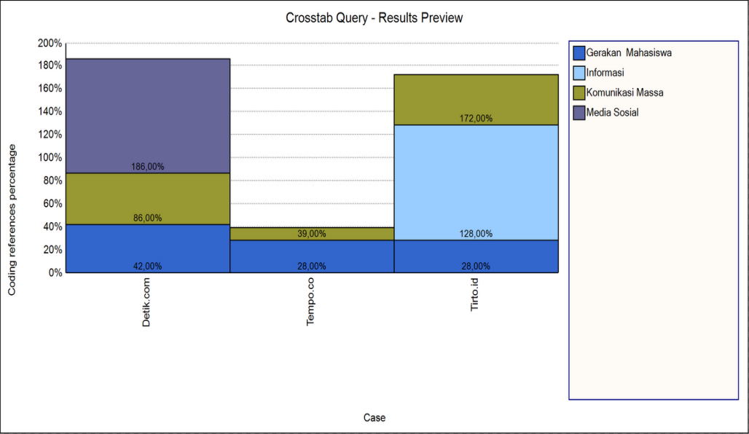
Source: Processed by researchers using NVivo12Plus (2019)
Figure 2. Crosstab Query Nvivo12 Plus
Crosstab query gives a quick way to check the deployment of encoding across cases and demographic variables. Based on the data on the dissemination of information through the Web news, Detik.com, Tempo.com and Tirto.id to the variables of the student movement, information, mass communication and social media as the social media variable if it is seen in the analysis data above that affect the dissemination of information so that the variable affects the information variable.
4.2 Analysis findings Cyber Activism (case study of Twitter usage in the dissemination of #Gejayanmemanggil information)
Social Media as the means of the most informant in the minatin of millennials and adults. The use of social media is not only the information obtained but the spread of issues very quickly, social media has changed a lot of the world began to emerge and develops that brings new communication in the community to the effect of all circles, but the consequences that arise should be wary of social media because it increasingly opens the opportunity for everyone to engage and free to take out opinions.
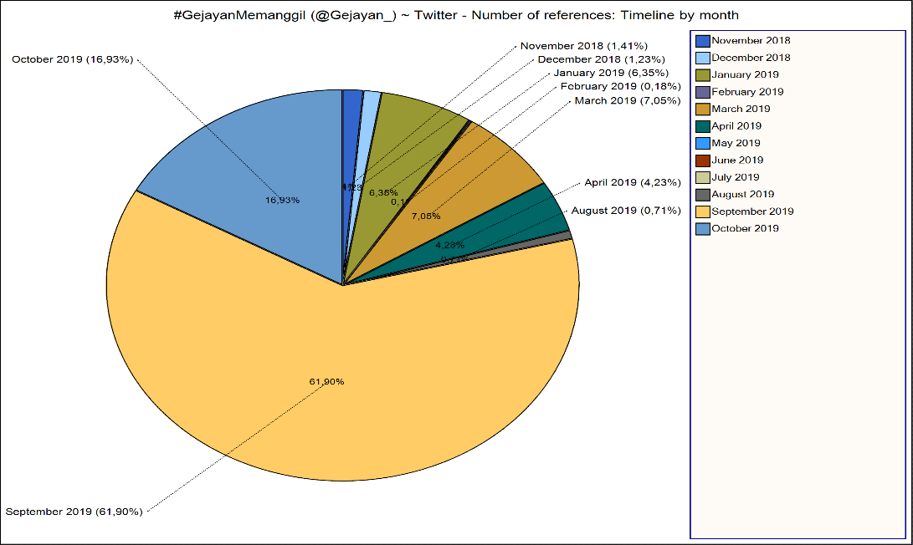
Source: Processed by researchers
using NVivo12Plus (2019)
Figure 3. Twitter Activity Intensities
Based on the above data, Social Media 2.0 has changed the lifestyle of the community with the ease of technology. This facility is utilized by all the community especially the millennial generation. This generation is a generation born from 1980 to 2000. Generations tend to use technological power in any activity or take information, social media to be a barometer for mass communication on the action of #Gejayanmemanggil, a medium that is a source of information on some community demands.
Social Media including Twitter, is a mass communication in information dissemination, Twitter activity intensities. The above data was taken through Nvivo12 Plus based on the data that Twitter @gejayanmemanggil most effectively in September 2019 in the Incarnation of the month it was in fact, but not only in September 2019 was seen from Diagram above in October 2019 Instensitin Twitter Activity @gejayanmemanggil is still popular, as one means of dissemination of information in the current digital revolution that gives a response to the student movement by giving Dissemination of the claim information among
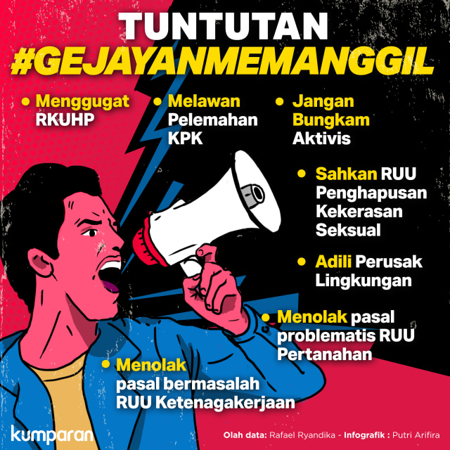
Figure 4: #Gejayanmemanggil demands. Photo: Princess Sarah Arifira/coil.
Sues claims are:
1. The urgent delay for rediscussion of problematic clauses in the RKUHP.
2. Urged the Government and PARLIAMENT to revise the newly ratified KPK LAW and reject all forms of weakening against the corruption eradication efforts in Indonesia.
3. To prosecute and prosecute the elites who are responsible for the environmental damage in Indonesia.
4. Reject the problematic articles in the employment BILL that are not on the sides of the worker.
5. Reject the problematical articles in the land Bill Airy is a to be treason to the spirit of agrarian reform.
6. Urgent ratification of the BILL of sexual abuse removal (MCC)
7. Encouraging the democratization process in Indonesia and Mengghentikan activist's arrest in various sectors (Kumparan.com 2019).
The above demands that affirm to the public that decisions are still central, then there is no more aspiration space and participation from civil society to the loss of freedom of expression of a society that must be accountable by the Government to assure Community welfare, protection, and security.
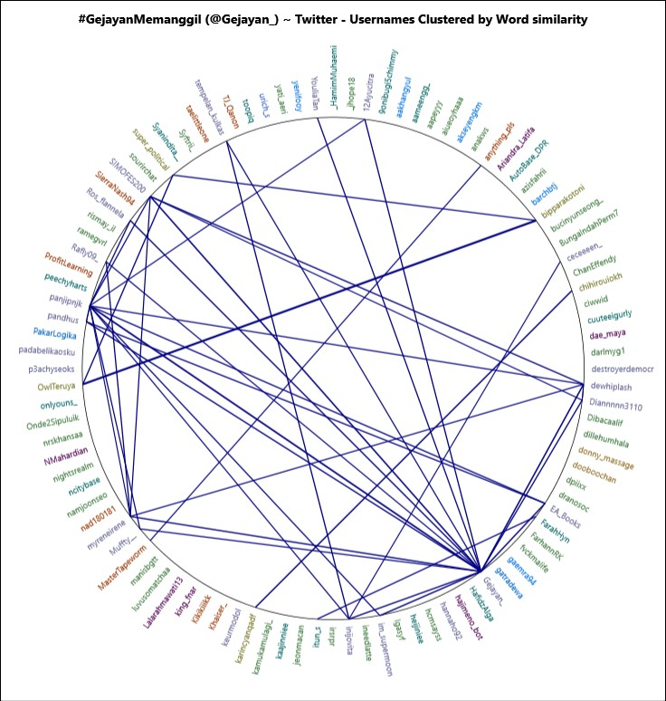
Source: Processed by researchers
using NVivo12Plus (2019)
Figure 5. Word Similarity Nvivo12 Plus
Based on the analysis of Word similarity Nvivo12 Plus, the information related to @gejayanmemanggil more effectively in the dissemination of information through a tweet account that with a very rapid impact to affect citizens in the dissemination of information to the color of the net Twitter. The higher the number of higher scale shows the ranking informant, the delivery of the communicant to the communicator by spreading the information through Twitter experienced a good response, and get a very rapid response so that in just a few days the people's alienation is popular in social media to voice or solicitation in action #gejayanmemanggil.
Mass communication as a process of communication through the mass media so that the purpose of communication to convey information to the community, it is the cause of feedback from mass communication which is the growing information that can be Conducted directly through social media. The picture also sees the utilization of social media in the means of information that creates the dissemination of information technology-based information to realize E-government that facilitates the development of technology in communication Mass.
- Kesimpulan
Some analysis of #Gejayanmemanggil action through Nvivo12 Plus data, effectiveness as a measure that will achieve the objectives that have been submitted, this research analyzes through Twitter, social media is not a new thing in the dissemination of information but social media especially Twitter, spreading the information of one of the action #Gejayanmemanggil to unite a vote in the aspiration of the student movement, impact of the effectiveness of the creation of schemes Which is the delivery of the information by consolidating the student movement to descend action on the road.
His special social Media Twitter became a key information tool in the millennial generation so that in the #Gejayanmemanggil, the action was very influential in the preconception of society. This is the utilization of social media to set scenario conducted by the People's Movement Alliance #Gejayanmemanggil by consolidating the students ' movements to descend the action on the road with three points of gathering, first at the Universitas Gadjah Mada roundabout (UGM), the main gate of the Sanata Dharma University, and the junction of a revolution of Sunan Kalijaga State Islamic University. After all gathered then the mobilization of time directed towards the T-junction of Colombo, Gejayan. Gejayan was once a witness of the revolutionary struggle of the New Order 1998 and on 23 September 2019. Repeating old history in the resistance movement of the ruling regime. Technically the action field runs safely and peacefully. The technical event, when located in the meeting of Gejayan in the content by the submission of opinion, especially critical to the government to hear the aspirations of students and civil society.
The role of information technology in the mass communication that has been used in #Gejayanmemanggil action is quite effective. This is evident in how the action takes place. The Indicator in measuring this is the high level of enthusiasm and participation of the students. Even the surrounding communities are down to the action #Gejayanmemanggil on 23 September 2019 and 30 September 2019.
Bibliography
Azman. 2018. “Penggunaan Media Massa Dan Media Sosial Di Kalangan Mahasiswa Komunikasi.” Jurnal Peurawi Vo,1 No,1.
Badri, Muhammad. 2016. “INFORMASI DAN KOMUNIKASI ( Studi Pada Gerakan Desa Membangun ).” Jurnal Risalah 27(2): 62–73.
Budiman, Haris. 2017. “Peran Teknologi Informasi Dan Komunikasi Dalam Pendidikan.” Al-Tadzkiyyah: Jurnal Pendidikan Islam 8(1): 31.
Cahyono, Anang Sugeng. 2016. “Pengaruh Media Sosial Terhadap Perubahan Sosial Masyarakat Di Indonesia.” Jurnal ilmu sosial dan ilmu politik diterbitkan oleh Fakultas Ilmu Sosial dan Politik, Universitas Tulungagung Vol 9, No: 140–57.
Dewantara, Ramma Wisnu, and Derajat S. Widhyharto. 2016. “Aktivisme Dan Kesukarelawanan Dalam Media Sosial Komunitas Kaum Muda Yogyakarta.” Jurnal Ilmu Sosial dan Ilmu Politik 19(1): 40.
Effendi, Muhammad Wahyu , Yan Hendra, Armansyah Matondang. 2019. “Persepsi Masyarakat Tentang Citra Pemerintah Kota Medan Community Perceptions of the Image of Medan City Government Through Instagram Social Media Account.” 8(1): 20–26.
Farhatiningsih, Lizzatul. 2018. “OPTIMIZATION OF INSTAGRAM USE IN THE PRACTICE OF GOVERNMENT PUBLIC RELATIONS.” Journal article Diakom: 1–9.
Febriyanti, Syafrida Nurrachmi, and Ririn Puspita Tutiasri. 2018. “Etika Komunikasi Netizen Di Media Sosial.” Jurnal Ilmu Komunikasi 1(1): 216–24.
Han, Sharon. 2019. “Weathering the Twitter Storm : Early Uses of Social Media as a Disaster Response Tool for Public Libraries During Hurricane Sandy.” (June).
Hayati, Laila. 2018. “Konsep Diri Anak-Anak Pengguna Aktif Media Sosial Laila Hayati.” Societ 6: 58–64.
Heywood, Andrew. 2014. Pustaka Pelajar Politik. Yogyakarta.
Huda, A Miftahul et al. 2017. “RANCANG BANGUN SISTEM INFORMASI PENGGOLONGAN PERAN PADA SISTEM PEMBELAJARAN UNIVERSITAS MENGGUNAKAN MEDIA SOSIAL.” Computatio: Journal of Computer Science and Information Systems 2: 124–34.
Kosasih, Iwan. 2016. “PERAN MEDIA SOSIAL FACEBOOK DAN TWITTER DALAM MEMBANGUN KOMUNIKASI (Persepsi Dan Motifasi Masyarakat Jejaring Sosial Dalam Pergaulan).” Journal of Chemical Information and Modeling 53(9): 1689–99.
Kumparan.com. 2019. 7 Tuntutan Mahasiswa Di Balik Aksi Damai Gejayan. Yogyakarta. https://kumparan.com/@kumparannews/7-tuntutan-mahasiswa-di-balik-aksi-damai-gejayan-1rv0kSzbdpM.
Liputan6.com. 2019. “Saat Gejayan Memanggil Ribuan Mahasiswa DIY Berkumpul.” https://www.liputan6.com/regional/read/4069768/saat-gejayan-memanggil-ribuan-mahasiswa-diy-berkumpul.
Muthohirin, Nafi. 2015. “Radikalisme Islam Dan Pergerakannya Di Media Sosial.” 11(2): 240–59.
Muya Syaroh Iwanda Lubis. 2018. “DAMPAK KOMUNIKASI DAN PERUBAHAN SOSIAL BAGI PENGGUNA INSTAGRAM (Studi Deskriptif Kualitatif Bagi Pengguna Media Sosial Instagram Di Instansi Dinas Pendidikan Sumatera Utara).” Jurnal Warta 10(2): 1–15.
Nurcahyo, Hendrawan, Purwito Adi, and Cahyo Edi. 2019. “Intensitas Media Sosial Terhadap Perkembangan Moral Siswa.” Jurnal Moral Kemasyarakatan 3(2): 57–63.
Prabowo, Agung dan Kurnia Arofah. 2017. “MEDIA SOSIAL INSTAGRAM SEBAGAI SARANA SOSIALISASI.” Komunikasi, Jurusan Ilmu (2): 256–69.
Pulungan, Hendra Kurnia. 2016. “PLURALISME DAN MEDIA.”
Qashmal & Ahmadi. 2015. “HUBUNGAN PENGGUNAAN MEDIA SOSIAL INSTAGRAM TERHADAP PEMBENTUKAN CITRA DIRI.”
Rahadi, Dedi Rianto. 2017. “Perilaku Pengguna Dan Informasi Hoax Di Media Sosial.” Jurnal Manajemen Dan Kewirausahaan 5(1): 58–70.
Rahman, Muh. Akil. 2016. “Pengaruh Penggunaa Media Sosial Terhadap Keputusan Pembelian Lewat Internet Di Kalangan Mahasiswa.” Assets (Jurnal Ekomomi, Manajemen, dan Akuntansi) 6(1): 103–15.
Rahmaniar, Alifa Wima, Martha Tri Lestari, and S Sos. 2019. “STRATEGI KOMUNIKASI DALAM SOSIALISASI PROGRAM LITERASI DIGITAL MELALUI MEDIA SOSIAL INSTAGRAM KEMENTERIAN KOMUNIKASI DAN INFORMATIKA COMMUNICATION STRATEGY IN SOCIALIZATION OF DIGITAL LITERATION PROGRAM THROUGH INSTAGRAM SOCIAL MEDIA MINISTRY OF COMMUNICA.” 6(1): 1819–27.
Rini, Sulistyo. 2016. “Pengaruh Good Governance Dan Pemanfaatan the Effect of Good Governance and Information Technology on Financial Departement Civil Servants Performance In.” (1): 1–14.
Rio Kurniawan, Didi Yulistyo. 2017. “Analisis Penggunaan Cerita Rakyat Bengkulu Dalam Pembelajaran Retorika/Komunikasi Massa.”
Setiadi, Ahmad. 2016. “Pemanfaatan Media Sosial Untuk Efektifitas Komunikasi.” Jurnal Humaniora 16(2): 1–7.
Sulthan, Muhammad, and S Bekti. 2019. “MODEL LITERASI MEDIA SOSIAL BAGI MAHASISWA.” Jurnal Aspikom Vol.3 No 6(12): 1076–92.
sutanto, herlena. 2017. “Efektivitas Penggunaan Instagram Melalui Tiga Tahap Analisis Pada Bebini Gelati Cafee.” Agora.
Trihayuningtyas, E., W. Wulandari, Y. Adriani, and S. Sarasvati. 2019. “MEDIA SOSIAL SEBAGAI SARANA INFORMASI DAN PROMOSI PARIWISATA BAGI GENERASI Z DI KABUPATEN GARUT.” Tourism Scientific Journal.
Warsihna, Jaka. 2019. “‘DILEMA’ PEMANFAATAN TEKNOLOGI KOMUNIKASI DAN INFORMASI (ICT) UNTUK MENINGKATKAN MUTU PENDIDIKAN.” : 60–76.
Watie, Errika Dwi Setya. 2016. “Komunikasi Dan Media Sosial (Communications and Social Media).” Jurnal The Messenger 3(2): 69.
Yaumi, Muhammad. 2017. “Integrasi Teknologi Informasi Dan Komunikasi Dalam Pembelajaran.” Lentera Pendidikan : Jurnal Ilmu Tarbiyah dan Keguruan 14(1): 88–102.

