JURNAL STUDI KOMUNIKASI
(Indonesian Journal of Communications Studies)

Revisions Form

This form should be fulfilled by the authors to respond suggestions of revision from the reviewers. In case the author decided not to accommodate the suggestion it should be listed below and explain the reason not to insert or revise the script. Please refer to the form from the reviewer and rewrite the comments from the reviewers along with the author’s revision.

No. | Comments and Suggestion from Reviewers | Revision from Authors | Inserted in Page/Part:
1 | Before Discussing this aspect please give a brief review about Ageism and Communication (MS2) | add physiological factors that are barriers to communication of elderly patients | 2
2 | What is BPJS? Unclear statement (MS3) | add an extension of BPJS | 3
3 | Unclear statement. You can compare to other previous work (MS4) | reinforce the statement by adding research explaining that health worker communication is the most influential factor in a patient's lifestyle | 2
4 | Put some Graphical Data (MS5) | a table of respondent characteristics has been added | 8-9
5 | Put some Graphical Data (MS6) | The number of visits each month has been added | 12
6 | So what’s the implication with Communication Theory, especially Health Comm. | Added that NLP can be used by nurses in fostering trusting relationships and educating patients | 17

By signing this document, the author declares that the author has made some revisions based on comments and suggestion from the reviewer.

Palopo, 31 January 2020

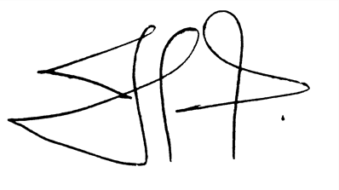

Edhy Rustan Hasriani

Note: Please fulfill this Form and upload in the Supplementary Files.

